ACES October Newsletter

School Newsletter - October 2024
Hello Students and Families,
Here are some important events happening at school over the next few weeks. Mark your calendars!

Upcoming Events:
Turkey Trot
October 7th to 10th
Get ready to run, walk, or trot! The Turkey Trot is a fun event where students can participate in and have a chance to win a turkey or a ham. It’s a great way to stay active and have fun with friends! For each lap, Primary students receive three coupons, Intermediate students can win 2 coupons, and Secondary receive one per lap. On Thursday, two coupons will be drawn. First prize is a small turkey, and second prize is a ham.
Science World Trip
October 10th
Science World, is coming to our school to present on Fantastic Forces. We will explore cool science exhibits and learn about the world around us. The presentation is at 1:30 PM to 2PM.
Thanksgiving Day - Statutory Holiday
October 14th, No School
Enjoy a long weekend to celebrate Thanksgiving! Remember, there will be no school on Monday, October 14th.
Terry Fox Run
October 15th
Join us for the Terry Fox Run to raise money for cancer research. Let’s come together as a school and run for a great cause! Be sure to bring your running shoes and your school spirit.
Pro-D Day
October 25th, No School
Teachers will be having a Professional Development day. There will be no school for students, but enjoy the day off!
Hallowe’en Fun Day
October 31st
Get ready for a spooktacular time! We will be celebrating Hallowe’en with fun activities, games, and maybe even a costume parade.
Just a quick reminder that we have outdoor activities everyday. Please come dressed for the weather. Always wear a jacket.

We hope you’re excited for all the fun activities ahead! Be sure to talk to your teachers for more details about each event.
Do You Like to Cook?
We are looking for a cook to help run our snacks and lunch programs. If you are interested, please submit a resume and cover letter to the school. The cover letter and resume can be addressed to Helen Wight. Currently, our senior students have been cooking for the lunch program.

Alexis Creek School has some job positions posted on School District #27’s website. We are looking
for a janitor, an Educational Assistant, and a part-time secretary. If you are interested, please apply through the School District’s website under Career opportunities, support staff.

We are looking for people who are interested in becoming involved with PAC. PAC meetings usually
take place after school and are held on Mondays. The first PAC meeting will be held after school on October 21st. All caregivers are welcome. Stay tuned for more PAC news.

Please do not hesitate to call the school if you have a question or concern. 250-394-4346.

Regards,
Helen Wight, Principal

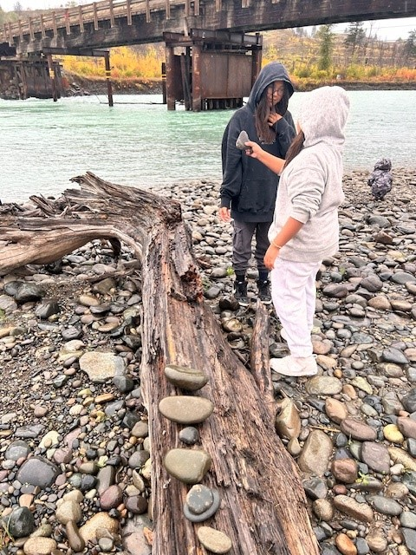

Recent highlights
Elder William Billyboy Sr. and Alvin Frank taught our students how to make rattles and drums.



