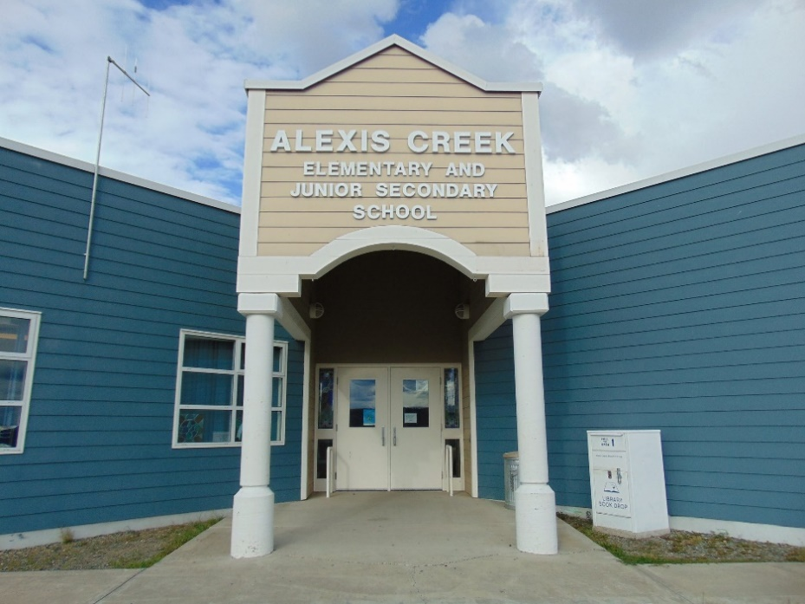
ACES January Newsletter
Ms. Wight
(250) 394 4346
helen.wight@sd27.bc.ca
Upcoming Events  PAC Meeting  Monday, January 29th at 3:05 in the Library  Kindergarten Registration, Monday, January 29th.  February 13th, Secondary report updates will be mailed out.  February 16^{th,} Pro-D.  February 19th, Family Day (Statutory Holiday)  March 18th to April 2nd,  Spring Break and Easter.  Spirit Days:  January 31st,  Jersey or Favorite Shirt  February 14th, Heart Day  February 21st, Beach Day  February 27th, Snow Day Events in PM.  February 29th, PJ Day and Pancake Brunch  March 15th, Shamrock Day. |  | Principal Thoughts  On January 29th, PAC will be meeting in the library afterschool. One of the items that we will be discussing is “Spirit Days”. If you would like to be involved in helping with special events, please drop by and join in with the PAC. We always looking for new members.  This month, we started holding “Spirit Days”. Spirit days are special days, where students can attend school by showing up dressed in the school’s theme for that day. On January 23rd, we held a “Stuffy Day”, and students brought their favourite stuffed toy to school. The stuffy got to spend the day in the classroom. Diana’s classes enjoyed having an imaginary tea party with their stuffies and their classmates.  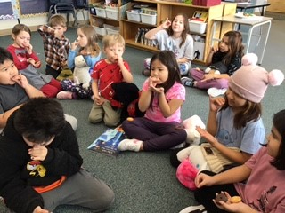  On January 31st, we will be holding “Jersey Day”, students can wear their favourite Jersey or shirt. In February, we are planning to have a “Fun Day in the Snow” in the afternoon of the 27th, please let me know if you would like to help with this event. On February 29th, we are holding a Pancake brunch and PJ Day, please let me know if you are interested in helping with this event.  I would like to thank Mrs. Ryskamp for volunteering her time to help in the school library.  Just one final reminder that Monday, January 29th, is kindergarten registration day.  Please don’t hesitate to call the school if you have a question or a concern, 250-394-4346.  Regards,  Ms. Helen Wight

