 |  | ACES September Newsletter
Ms. Wight  (250) 394 4346  helen.wight@sd27.bc.ca |  | 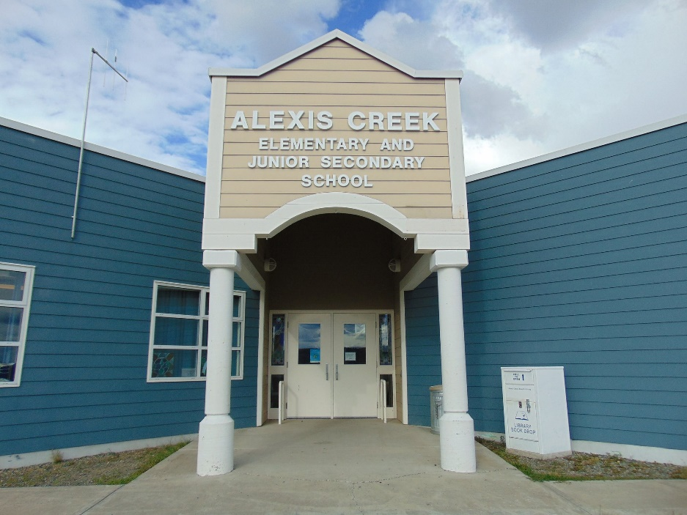
Upcoming Events  School Field Trip to Bull Canyon and Chilcotin Lady who turned into Stone.  09.25  Professional Development Day  09.23 No School  Statutory Holiday  Truth and Reconciliation Day  09.30 No School  Upcoming Events for Next Month  Terry Fox Run  Hallowe’en events |  | Principal Thoughts  It has been a busy first two weeks of school. Staff have worked hard at creating a clean, warm, and welcoming school environment for our learners. It is great to see many of our students return to  school, and we getting to know our new students and families.  We are back to having three divisions this year. Ms. Haley Usher is teaching K to grade 4, Ms. Diana Kershaw is teaching grades 5 to 7, Ms. Helen Wight is teaching grades 7 to 11. Annette Frank is our Chilcotin Language and Culture teacher.  Senior and Junior students are learning their core subjects: Math, English, Social Studies, and  Science through the distancing learning program run by Kool School, Kamloops. Grades 8 to 10 students are getting to know their online teachers, and we are emerging into our routines.  Students continue to follow the Alexis Creek School tradition of beginning our days with breakfast,  and daily k to 10 activities in the gym, or outside. A healthy snack program is offered daily, and a  hot lunch program runs from Mondays to Thursdays.  We are looking for a cook to help run our snacks and lunch programs. If you are interested, please submit a resume and cover letter to the school. The cover letter and resume can be addressed to Helen Wight. Currently, our senior students have been cooking for the lunch program.  Alexis Creek School has some job positions posted on School District #27’s website. We are looking  for a janitor, an Educational Assistant, and a part-time secretary. If you are interested, please apply through the School District’s website under Career opportunities, support staff.  We are looking for people who are interested in becoming involved with PAC. PAC meetings usually  take place after school and are held on Mondays. The first PAC meeting will be held after school on October 7th. All caregivers are welcome. Stay tuned for more PAC news.  Please make note of the following dates on the left of this newsletter. On September 25th, we are  going on a field trip to Bull Canyon to learn about the village site, and to collect river rocks for a  special rock painting project. Afterwards, we will visit the sacred spot where the Chilcotin Lady turned to Stone. Students are invited to make offerings. On September 26th, we will be working on a special school project in recognition of Orange Shirt Day.  Monday, September 23rd, it is a Professional Day for teachers. There is no school for students.  Monday, September 30th, is a statutory Holiday in recognition of Truth and Reconciliation Day. In October, we will be hosting a Terry Fox Run. More details will come in our next Newsletter.  Please do not hesitate to call the school if you have a question or concern. 250-394-4346.  Regards,  Helen Wight, Principal  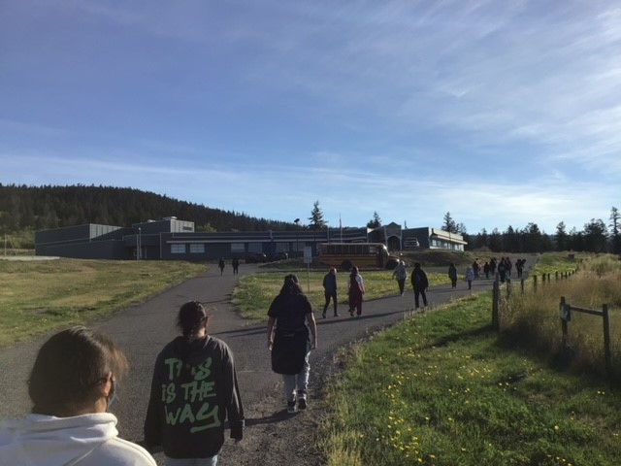

Recent highlights
Elder William Billyboy Sr. and Alvin Frank taught our students how to make rattles and drums.

