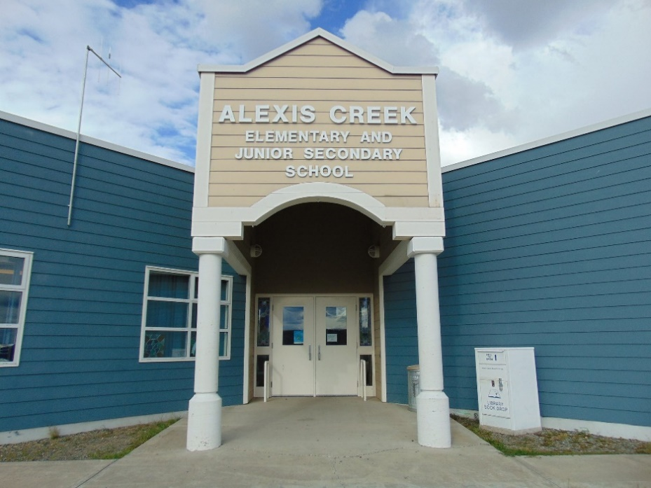
ACES February Newsletter
Ms. Wight
(250) 394 4346
helen.wight@sd27.bc.ca
Upcoming Events  PAC Meeting  Monday, February 26th at 3:05 in the Library  February 28th, is Pink Shirt Day  March 15th, St. Patrick’s Day  March 29th, Good Friday.  March 18th to April 2nd,  Spring Break and Easter.  Spirit Days:  February 27th, Snow Day Events in PM.  February 29th, PJ Day and Pancake Brunch  March 15th, Shamrock Day. |  | On February 26th, PAC will be meeting in the library afterschool.  If you would like to be involved in helping with special events, please drop by and join in with the PAC. We always looking for new members.  This month, we held two Spirit Days events. The first one was on Valentine’s Day, and for it we played a school wide game throughout the day. Each girl had three hearts, and if a boy could get a girl to talk, she would have to give him her heart. There was a lot of trickery going on, but it was all in fun. On February 21st, we held “Beach Day” and anyone who wanted to, could wear sunglasses, or a beach hat, or walk around in their favorite shorts inside the school. Each class had a fishpond event where students could win a small prize. In the afternoon was a cookie decorating station where students decorated ocean themed cut out cookies.  This Wednesday is the anti-bullying campaign event “Pink Shirt Day.  Lastly, on Thursday, we will be having a pancake brunch. Senior students will prepare, cook, and serve the school pancakes, sausages, and fruit to celebrate the special leap year day February 29th.  Again, I would like to thank Mrs. Ryskamp for volunteering her time to help in the school library.    Please don’t hesitate to call the school if you have a question or a concern, 250-394-4346.  Regards,  Ms. Helen Wight

